**K.V.R Govt. College for Women (A) ,NCC Activities 2021-22**

**YOGA DAY CELEBRATIONS**



**Date :** 21.06.21

**Name of the Participants :** Staff ,NCC Cadets and Students

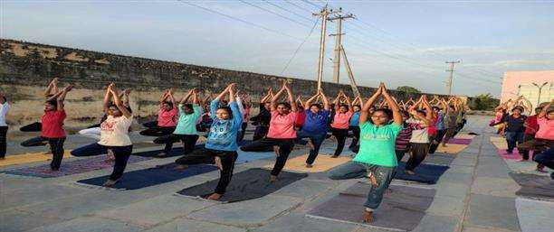

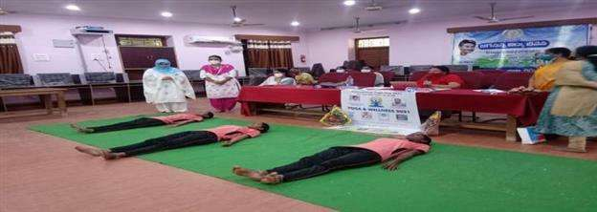

**Brief Report :** Yoga Day was celebrated in collaboration with Dept.of Physical Eucation,NCC and NSS.It was celebrated with great enthusiasm.All the NCC cadets and students have participated in the Yoga Day celebrations.

**Outcome:** NCC Cadets and other students came to know the importance of Yoga.

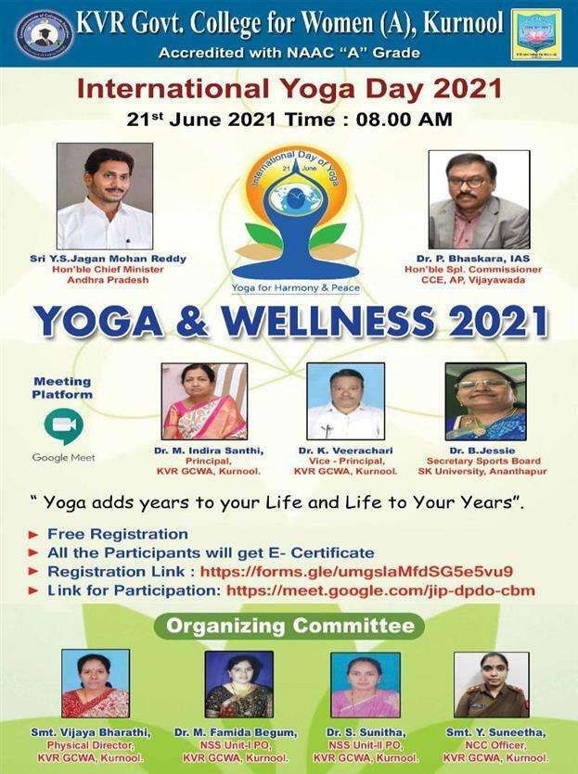

**K.V.R Govt. College for Women (A) ,NCC Activities 2021-22**

**TREE PLANTATION ON THE OCCASION OF YSR BIRTHDAY**



**Date :** 8.07.21

**Name of the Participants :** Staff and NCC Cadets

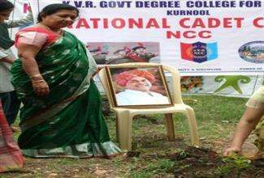

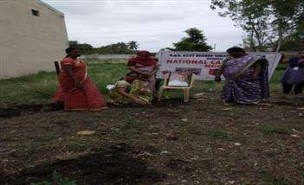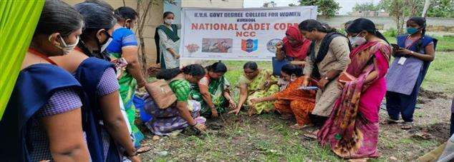

**Brief Report :** Tree plantation programme was conducted on 8 July in the view of Y.S.Rajasekhar Reddy jayanthi.

**Outcome:** Principal Dr.M.Indira Shanthi Garu ,all the lecturers ,NCC Cadets and other students have participated in the programme .saplings were planted on the campus.

**K.V.R Govt. College for Women (A) ,NCC Activities 2021-22**

**AWARENESS ON DISHA APP**



**Date :** 31.07.21

**Resource person:** Police Dept.

**Name of the Participants:** NCC Cadets and Students

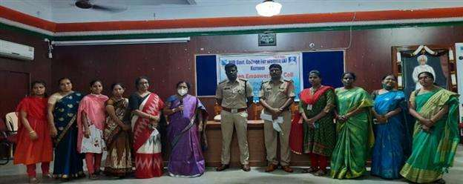 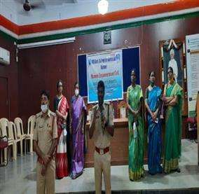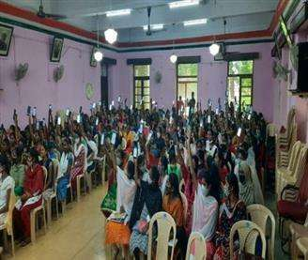

**Brief Report :** Awareness on DISHA app was conducted by the Police Dept.with the support of NCC and NSS and WEC units of the college.

**Outcome:** Principal Dr.M.Indira Shanthi Garu , WEC Coordinator ,NCC Officer ,NCC Cadets and other students have participated in DISHA app Awareness programme .Students have downloaded the app and learnt how to use the app.

**K.V.R Govt. College for Women (A) ,NCC Activities 2021-22**

**VANAM MANAM PROGRAMME**



**Date :** 5.08.21

**Name of the Participants :** Staff & NCC Cadets

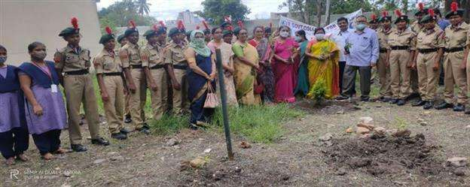

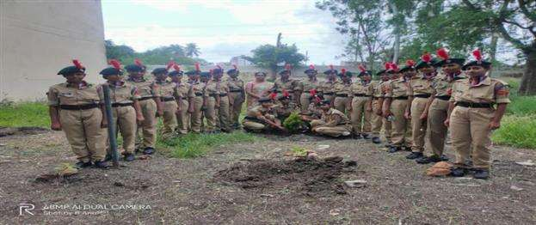

**Brief Report :** Vanam Manam programme was conducted on the campus of K.V.R.College .

**Outcome:** Principal Dr.M.Indira Shanthi Garu , Lecturers ,NCC Officer ,NCC Cadets and other students have participated in Vanam Manam programme .Saplings were planted by the principal,staff and the cadets.

**K.V.R Govt. College for Women (A) ,NCC Activities 2021-22**

**INDEPENDENCE DAY CELEBRATIONS**



**Date :** 15.08.21

**Resource Person :**  Principal

**Name of the Participants :** Staff & NCC Cadets

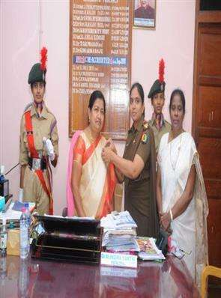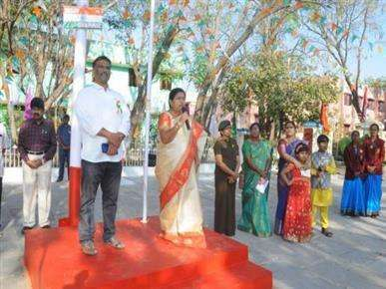

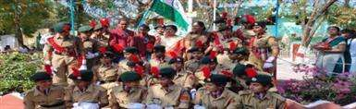

**Brief Report :** INDEPENDENCE DAY was celebrated on the campus of K.V.R.College with great enthusiasm and patriotic fervor.

**Outcome:** Principal Dr.M.Indira Shanthi Garu , Lecturers ,NCC Officer ,NCC Cadets and other students have participated in INDEPENENCE DAY celebratons .NCC Cadets performed Drill and gave Guard of Honour.

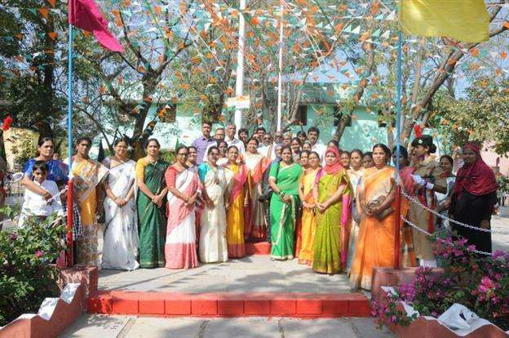

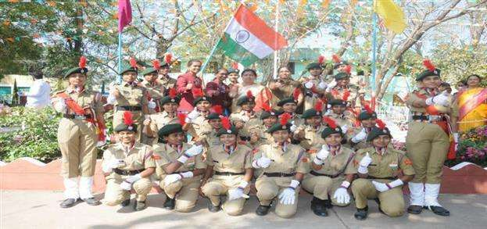

**K.V.R Govt. College for Women (A) ,NCC Activities 2021-22**

**AWARENESS PROGRAMME ON COVID-19**



**Date :** 26.08.21

**Resource Person :**  Health Dept.Kurnool

**Name of the Participants:** NCC & NSS units

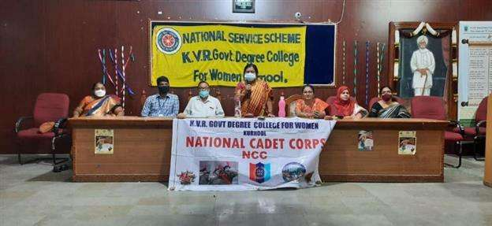 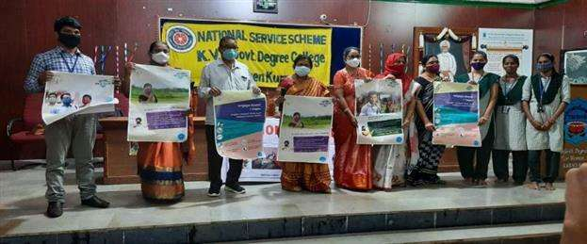

**Brief Report :** COVID awareness programme was held at K.V.R.Govt.College for Women .Principal madam ,NCC &NSS officers and students have participated in the programme .

**Outcome:** Students came to know the consequences of Covid 19 and the precautions to take to stop this panemic disease.

**K.V.R Govt. College for Women (A) ,NCC Activities 2021-22**

**CONFERENCE ON NEW YOUTH POLICY**



**Date :** 03.09.21

**Resource person :** SETKUR CEO

**Name of the participants :** NCC & NSS

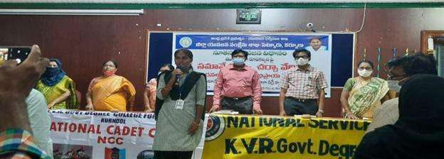

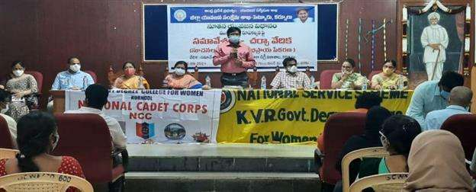

**Brief Report :** A Conference was held at K.V.R.Govt.College for Women on drafting of New Youth Policy.SETKUR CEO attended the programme.

**Outcome:** Principal Dr.M.Indira Shanthi Garu , IQAC Coordinator ,NCC Officer , NSS Coordinators, NCC Cadets and other students and guests,intellectuals from all over the district have participated in the discussion and gave their suggestions for the drafting of New Youth Policy.

**K.V.R Govt. College for Women (A) ,NCC Activities 2021-22**

**AZADI KA AMRUTH MAHOTHSAV-CYCLE RALLY**



**Date :** 06.09.21

**Resource Person :**  Athena school

**Name of the Students :** NCC cadets

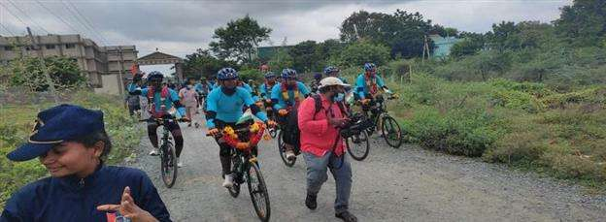

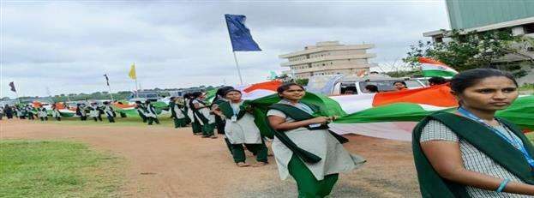

**Brief Report :** NCC Cadets and NCC Officer,NSS Students and NSS coordinators have participated in the welcoming ceremony of CRPF Cycle Rally team who have taken the herculean task of cycling from Kanyakumari to Kashmir as the part of Azadi ka Amruth Mahosthsav . The programme was held at Athena School.

**Outcome:** All the NCC Cadets and NSS Volunteers were inspired by seeing the dedication and the patriotic fervor of the CRPF Jawans towards their Mother land.

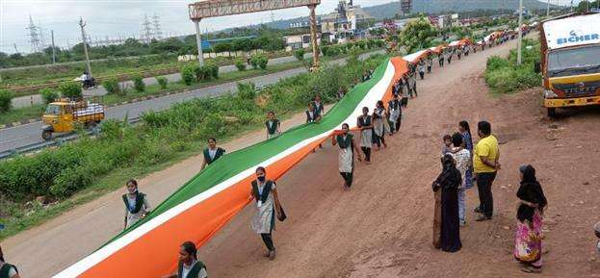

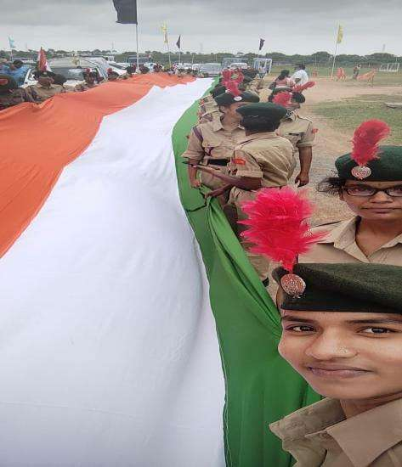

**K.V.R Govt. College for Women (A) ,NCC Activities 2021-22**

**BOOK RELEASE FUNCTION OF THERESAMMA**



**Date :** 06.09.21

**Name of the participants :** NCC cadets , NSS Volunteers and Celebrities of Kurnool

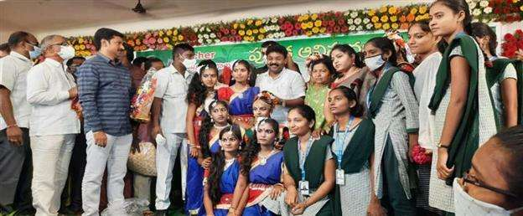

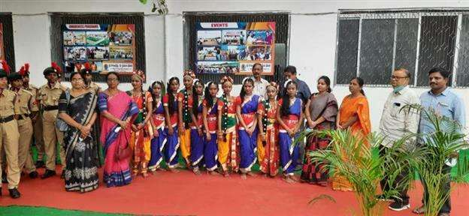

**Brief Report :** NCC Cadets , NCC Officer,Cultural team of K.V.R.Govt.College for Women have participated in the Book release function of Theresamma ,educationalist and mother of Education Minister Sri Adimulapu Suresh garu.

**Outcome:** The Cadets and students came to know the greatness of Theresamma Teacher and about her priceless services rendered to the Education field.

**K.V.R Govt. College for Women (A) ,NCC Activities 2021-22**

**SWATCH BHARATH ACTIVITY**



**Date :** 16.09.21

**Name of the Participants :** NCC cadets

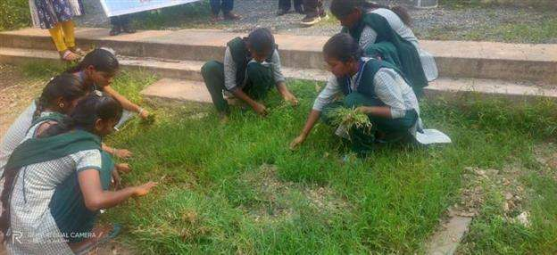

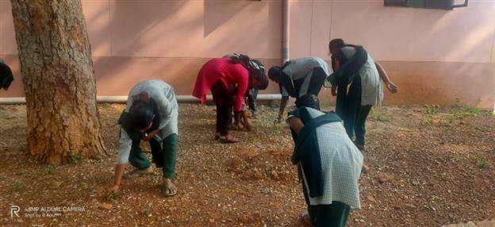

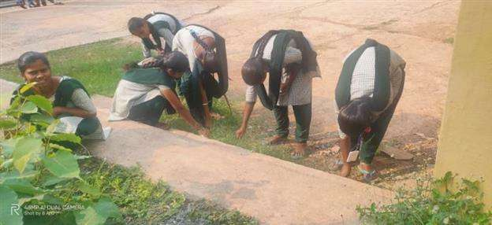

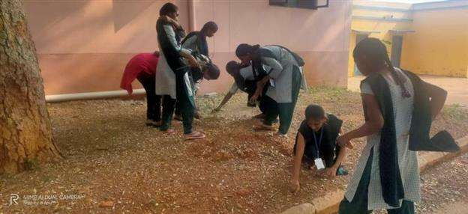

**Brief Report :** NCC Cadets participated in Swatch Bharath activity.Removed papers , plastic and weed plants on the campus.

**Outcome:** The Cadets inspired other students to take up such activities.

**K.V.R Govt. College for Women (A) ,NCC Activities 2021-22**

**INTERACTION WITH DDG**



**Date :** 17.09.21

**Resource Person :**  GROUP COMMANDER

**Name of the Participants :**  Officers, ANO’s & PI Staff

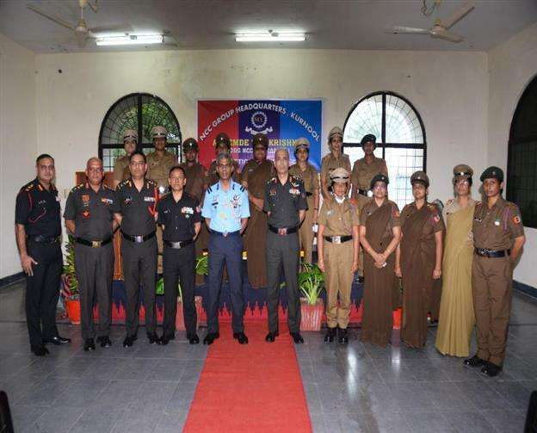

**Brief Report :** DDG –SECUNDERABAD had an interactive session with all the ANO’s ,CTO’S and with all the officers of Kurnool group on 17 th SEP. at Silver Jubilee College ,Kurnool.

**K.V.R Govt. College for Women (A) ,NCC Activities 2021-22**

**EKTHA DIWAS**



**Date :** 31.09.21

**Resource Person :**  District Police

**Name of the Students :** NCC cadets

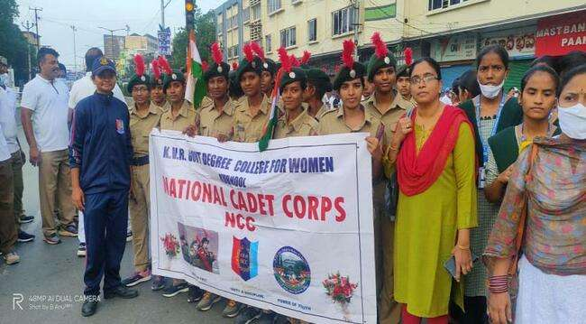

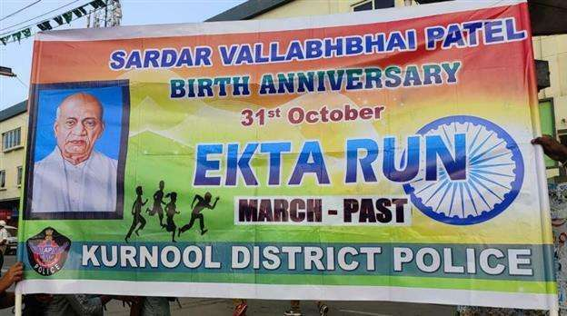

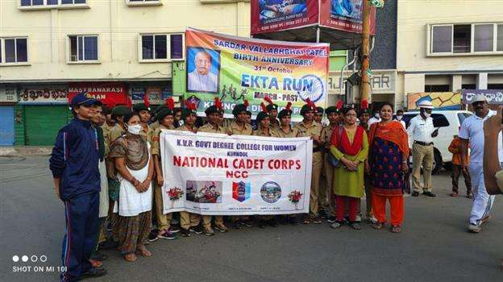

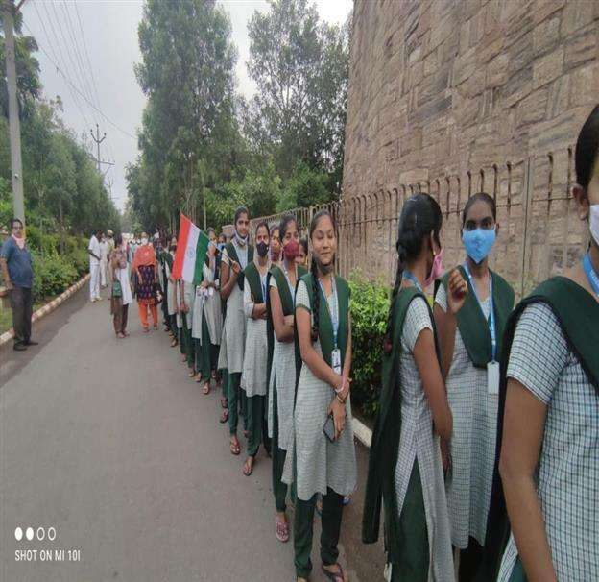

**Brief Report :** NCC Cadets & NSS Volunteers of K.V.R.Govt.College For Women participated in EKTHA RUN conducted by District Police.The Run was carried out from Konda Reddy fort to Raj Vihar circle.

**Outcome:** The EKTHA RUN is every year carried out on the occasion of the birth anniversary of Sardar Vallabhai Patel,The Iron Man Of India.

Cadets remembered the services of Patel rendered to the Nation.

**K.V.R Govt. College for Women (A) ,NCC Activities 2021-22**

**GANGA UTHSAV**



**Date :** 02.11.21

**Name of the Resource person :**  Y.SUNEETA ,ANO

**Name of the participants :**  NCC Cadets

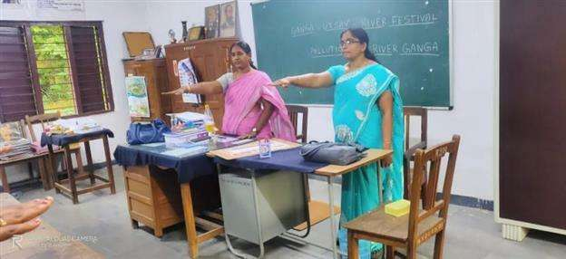

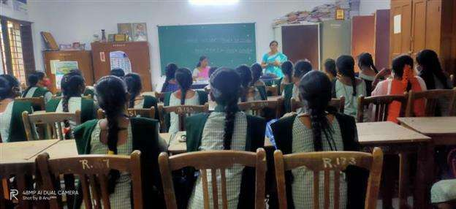

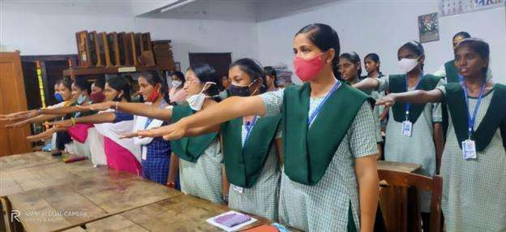

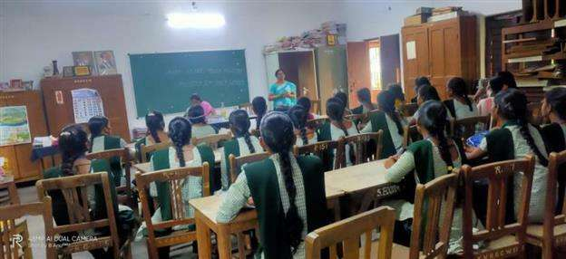

**Brief Report :** NCC Cadets of K.V.R.Govt.College For Women participated in GANGA UTHSAV activity where the ANO Y.SUNEETA and guest lecturer P.SRAVANTHI had taken the awareness class regarding cleaning of GANGA and prevention of pollution in GANGA and other water bodies.

**Outcome:** The cadets came to know the importance of water bodies and how to prevent the pollution of water bodies.

**K.V.R Govt. College for Women (A) ,NCC Activities 2021-22**

**ONLINE EBSB SAPTHAH**



**Date :** 25.11.21

**Name of the Resource person :**  Y.SUNEETA ,ANO

**Name of the Participants :**  NCC Cadets- Rohini,Triveni,Madhu Divya, Keerthi Priya

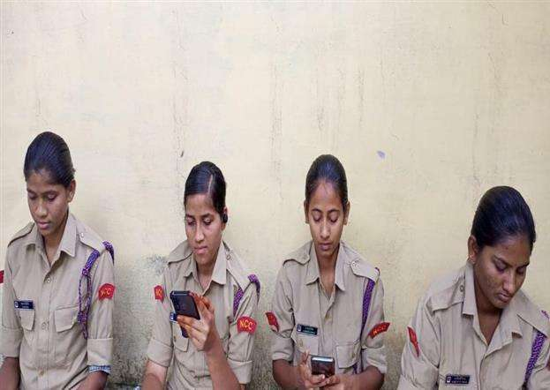

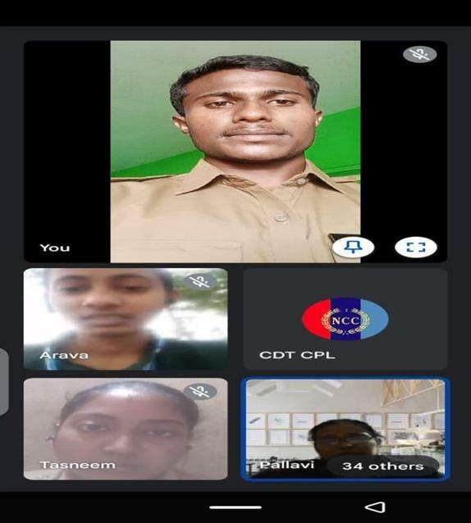

**Brief Report :** 4 NCC Cadets of K.V.R.Govt.College For Women participated in online EBSB activity where the ANO Y.SUNEETA acted as coordinating ANO from 9 Andhra Girls Battalion.

**Outcome:** The cadets participated with great enthusiasm ,prepared PPT’s and took part in cultural activities.They came to know the importance of National Integration.

**K.V.R Govt. College for Women (A) ,NCC Activities 2021-22**

**NCC DAY CELEBRATIONS- BLOOD DONATION**



**Date :** 27.11.21

**Name of the Resource person :**  9 ANDHRA GIRLS BATTALION

**Name of the Participants :**  Officers, ANO’s & NCC Cadets

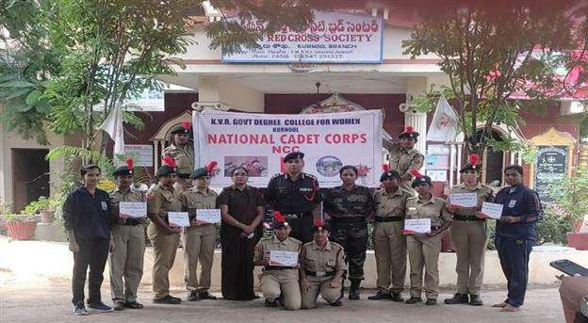

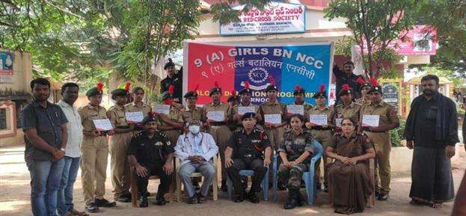

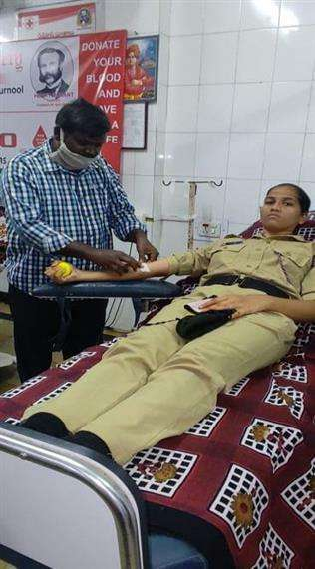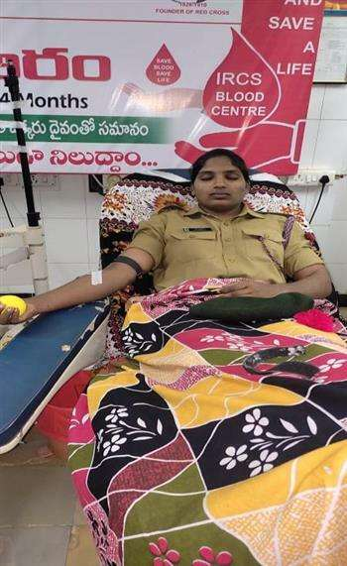

**Brief Report :** As the part of NCC Day celebrations Cadets of K.V.R.Govt.College For Women participated in Blood donation camp.Two cadets of our college have donated blood .The programme was organized by 9 Andhra Girls Battalion.

**Outcome:** The cadets came to know the importance of Blood donation and realized the blood donated by them would save many lives.

**K.V.R Govt. College for Women (A) ,NCC Activities 2021-22**

**WORLD AIDS DAY**



**Date :** 1.12.21

**Name of the Resource person :**  9 ANDHRA GIRLS BATTALION

**Name of the Participants :**  Officers, NCC Cadets

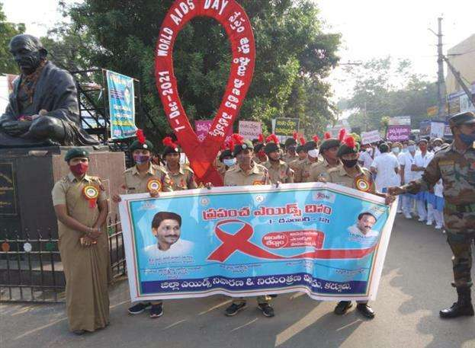

**Brief Report :** Cadets of K.V.R.Govt.College For Women participated in AIDS DAY Rally organized by 9 Andhra Girls Battalion.The Rally took place from Raj Vihar center to Collectorate.

**Outcome:** The Cadets got the awareness on AIDS

**K.V.R Govt. College for Women (A) ,NCC Activities 2021-22**

**NATIONAL COMMUNAL HARMONY WEEK**



**Date :** 7.12.21

**Name of the Resource person :**  9 ANDHRA GIRLS BATTALION

**Name of the Participants :**  NCC Cadets

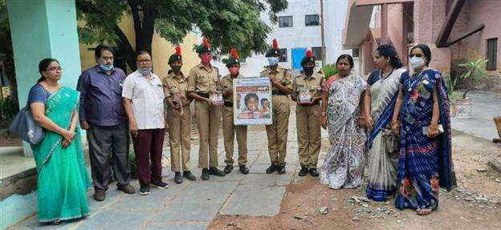

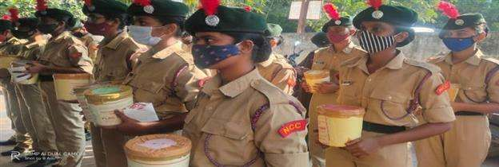

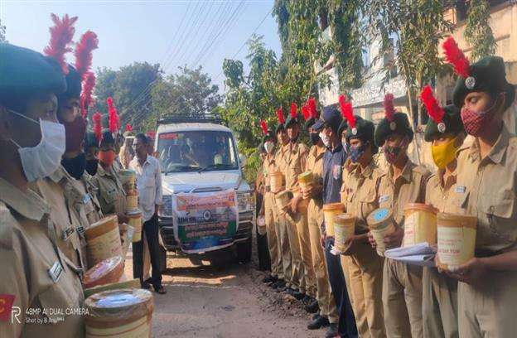

**Brief Report :** Cadets of K.V.R.Govt.College For Women participated in Communal Harmony Week Rally organized by 9 Andhra Girls Battalion.The Rally took place from Raj Vihar center to Collectorate.

**Outcome:** The Cadets showed their gratitude towards Jawans by collecting funds for the welfare of the soldjers.

**K.V.R Govt. College for Women (A) ,NCC Activities 2021-22**

**CONDOLENCE MEETING OF CDS GEN.BIPIN RAWATH**



**Date :** 13.12.21

**Name of the Resource person :**  9 ANDHRA GIRLS BATTALION

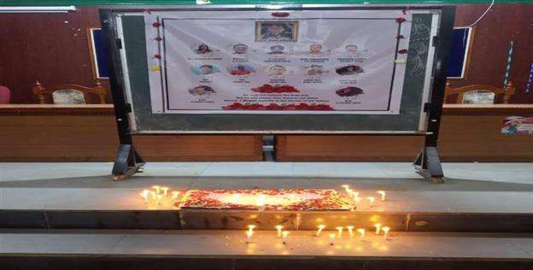

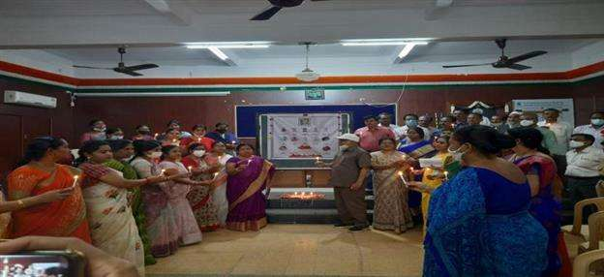

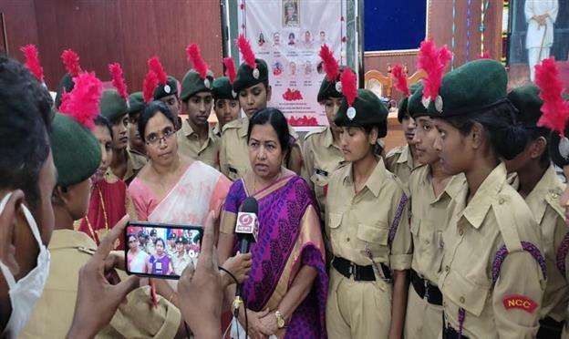

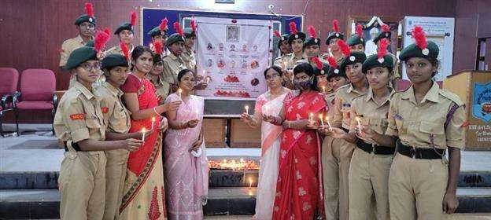

**Brief Report :** Cadets of K.V.R.Govt.College For Women participated in Condolence meet of the departed souls of CDS Gen.Bipin Rawath and other members. Principal and all the staff of the college observed two minutes silence in respect of the diseased.

**Outcome:** The cadets paid their tribute to the immortal souls and got inspired from them in terms of dedication towards duty, patriotism .

**K.V.R Govt. College for Women (A) ,NCC Activities 2021-22**

**Jagananna Swatch Sankalp**



**Date :** 5.1.2022

**Name of the Activity : Jagananna Swatch Sankalp**

**Name of the Resource person :**  Y.Suneeta

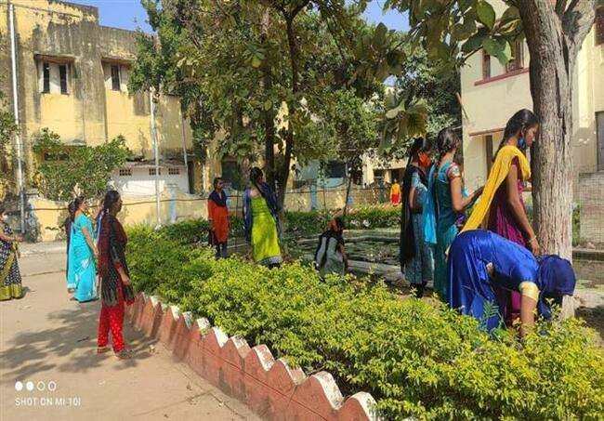

**Brief Report :** NCC Cadets of K.V.R.Govt.College For Women participated in Swatch pakhwada programme and cleaned the premises of the college.

**Outcome:** NCC cadets are participating regularly in cleanliness programmes that were scheduled on every Saturday as part ofv the Jagananna Swatch Sankalp[ programme.

**K.V.R Govt. College for Women (A) ,NCC Activities 2021-22**

**Blood Donation Camp**



**Date :** 7.2.2022

**Name of the Activity :Blood Donation Camp**

**Name of the Resource person :**  RED CROSS SOCIETY ,KURNOOL &NCC,NSS &RRC Units of K.V.R.Govt.College for Women.

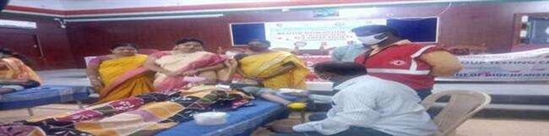

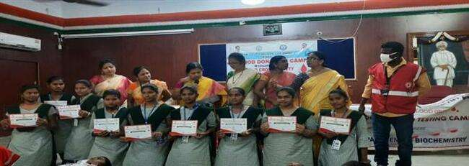

**Brief Report :** Blood Donation Camp was conducted by NCC and NSS units &RRC of the college in collaboration with Red cross society and as part of this programme students have donated nearly 25 units of Blood to the Red Cross Society.

**Outcome:** NCC cadets and other students are motivated by this programme and they appreciated the fellow students for donating the Blood and saving the lives.

**K.V.R Govt. College for Women (A) ,NCC Activities 2021-22**

**FIRING THROUGH SIMULATOR**



**Date : 9**.3.2022

**Name of the Activity :Firing practice through Simulator**

**Name of the Resource person :9 Andhra Girls Batallion**

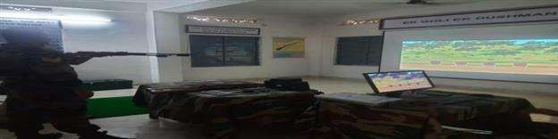

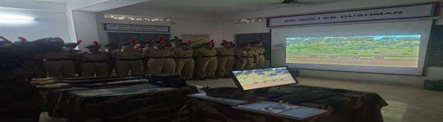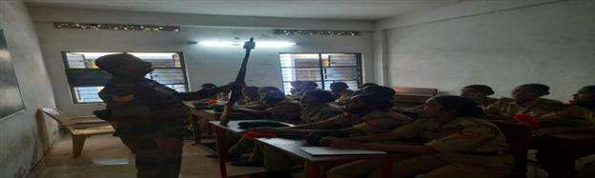

**Brief Report :** 25 cadets have practiced firing through Simulator at Silver Jubilee College,Kurnool.

**Outcome:** NCC cadets learnt the skills of Firing and were motivated to participate in such other programmes.

**K.V.R Govt. College for Women (A) ,NCC Activities 2021-22**

**TREKKING CAMP**



**Date : 27**.3.2022

**Name of the Activity :Trekking Camp**

**Name of the Resource person :**  Dept.of Physical Education ,NCC & NSS Units of K.V.R.Govt.College for Women

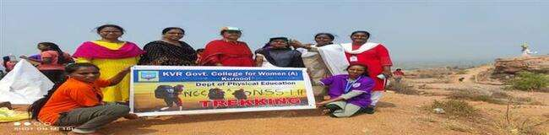

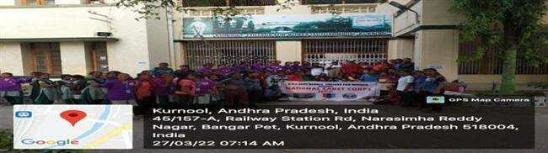

**Brief Report :** Trekking Camp was conducted by Physical Education,NCC and NSS units of the college on 27-03-2022 .Trekking was done from Dinnedevarapadu village to Jagannatha Gattu,Kurnool. 6 lecturers &150 students have participated in trekking camp.

**Outcome:** NCC cadets and other students are motivated and inspired by this programme and they participated enthusiastically and learned the qualities of togetherness, unity , leadership, endurance and the fun of exploring the unknown world.